**“Key environmental challenges and opportunities of the new legislative term”**

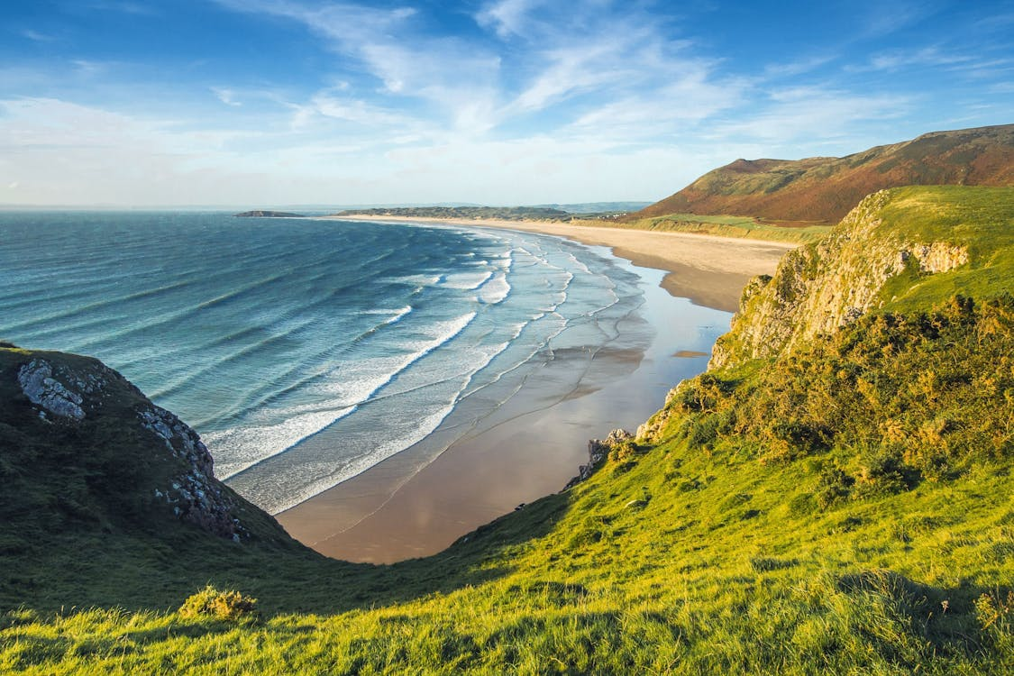

**Tuesday 19th November 2024 at 15:30 – 17:30 CET**

**Organized at the European Committee of the Regions (CoR), Room JDE 51**

**Co-hosted by MEPs Elsi Katainen (Renew Europe), André Rodrigues (S&D), and Dimitris Tsiodras (EPP)**

**Co-Chairs of the EP Intergroup on 'Climate Change, Biodiversity, and Sustainable Development'**

This upcoming event organized by the EP Intergroup on 'Climate Change, Biodiversity, and Sustainable Development' will serve as a vital opportunity to present and discuss the Intergroup’s 2024-2029 policy priorities and work programme ahead, specifically addressing sustainable food systems, sustainable forest management, water resilience, circular economy & the bioeconomy, clean energy & transport, and ocean governance. The event will provide an opportunity to foster collaboration and reinforce partnerships among MEPs and policy-makers from EU institutions and UN agencies, stakeholders from the private sector and civil society, engaging them in an open dialogue to align on these policy priorities and drive impactful action for a more sustainable future.

In addition, this event will focus on raising awareness around the re-establishment of the EP Intergroup. By welcoming new and returning MEPs, Assistants and Policy Advisors, the event aims at maximizing outreach and ensuring broad support for the Intergroup’s initiatives. Last but not least, the event will offer stakeholders from different sectors, researchers and the civil society the chance to engage in the conversation and contribute to the ongoing work of the EP Intergroup, fostering collaborations, promoting partnerships and boosting the role of science and innovation.

**FINAL AGENDA**

**15:30 – 15:50:** Opening remarks by:

* + **Ilias Grampas**, Deputy Director, EBCD
  + **MEP Dimitris Tsiodras** (EPP, Greece)
  + **MEP André Rodrigues** (S&D, Portugal)
  + **MEP Elsi Katainen** (Renew Europe, Finland)

**15:50 – 16:05:** Keynote speech by **Dr. Janez Potočnik**, Co-Chair of UNEP International Resource Panel (IRC) and former European Commissioner for the Environment, Oceans and Fisheries

**16:05 – 16:15:** Intervention by **Jan Dusik**, Deputy Director-General, DG CLIMA

**16:15 – 16:35:** Reactions by EP Intergroup’s Advisory Group Members:

* + **Vadim Kononenko**, EU Interinstitutional Relations and Strategic Foresight Expert, EEA
  + **Françoise Bonnet**, Secretary General, ACR+
  + **Anna Papagrigoraki**, Sustainability Director, Cepi
  + **George Karkampasis**, Director - Circular Economy & Raw Materials, European Aluminium
  + **Nathalie Gamain**, Secretary General, EPO

**16:35 – 17:20:** Q&A session with the audience, including reactions by more Members of the European Parliament:

* + **MEP Paulo do Nascimento Cabral** (EPP, Portugal)

**17:20 – 17:25:** Intervention by **Kata Tüttő**, First Vice-Chair of the ENVE Commission, Committee of the Regions

**17:25 – 17:30:** Closing remarks by **MEP Dimitris Tsiodras** (EPP, Greece)