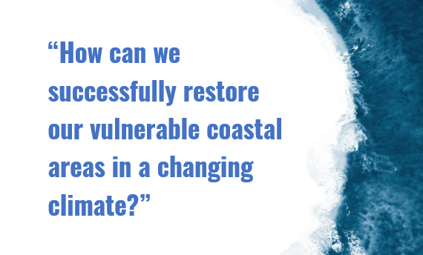

Thursday 6th November 2025 at 08:00 – 09:30 CET
Organised at the European Parliament, Brussels (MEP Salon area)



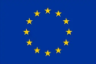 | This project receives funding from the European Union’s Horizon 2020 research and innovation programme, under Grant Agreement 101037097

BACKGROUND INFORMATION

Coastal ecosystems play an invaluable role in maintaining biodiversity and climate resilience, as well as providing essential ecosystem services that support communities and economies. However, they are under increasing threat from rising sea levels, erosion, habitat degradation and extreme weather events. Furthermore, these pressures are expected to intensify due to the triple planetary crisis of climate change, biodiversity loss and pollution.

In this context, strong, coherent and integrated policy frameworks are essential for scaling up coastal restoration and meeting EU and international commitments. A significant milestone was reached in 2024 with the adoption of the EU Nature Restoration Regulation (NRR), which establishes legally binding restoration targets for degraded ecosystems across Member States, including coastal and marine areas. Member States are now required to develop National Restoration Plans, outlining how they intend to meet these targets. Meanwhile, COP30 in Belém, Brazil, provides an important opportunity to reinforce the global commitment to climate action and align restoration efforts with the climate objectives of the Paris Agreement.

This timely event will explore how coastal restoration can be elevated within national and EU policies to deliver on climate and biodiversity objectives. With a focus on developing Nature Restoration Plans (NRPs), the discussion will highlight opportunities to embed coastal resilience within broader environmental and climate strategies in the lead-up to COP30.

Bringing together EU policymakers, national representatives, and experts, the session will examine how frameworks such as the NRR, the Paris Agreement, and the Kunming-Montreal Global Biodiversity Framework can be better aligned to support effective, large-scale coastal restoration. The session will also identify recommendations to ensure policy coherence, enhance implementation and promote restoration as a key strategy for climate adaptation and biodiversity recovery in coastal areas.

The REST-COAST project, part of the so-called Green Deal Restoration Cluster, has produced several policy outputs aimed at informing policymakers on best practices for coastal ecosystem restoration. Particular attention was given to the EU policy processes and key relevant multilateral environmental agreements, such as the UNFCCC and the Regional Seas Conventions. This event is held within the framework of REST-COAST Work Package 5, focused restoration-supportive governance that better integrates policies and mechanisms for large scale coastal restoration.

Explore REST-COAST Policy Recommendations scanning the QR codes or clicking the links:

  EU Nature Restoration Regulation and REST-COAST: Setting the Basis for Coastal Restoration |   Unlocking the potential of coastal restoration to strengthen climate action: Opportunities for the NDCs |   Connectivity’s role in maintaining coastal resilience: Key insights from restoration initiatives to enhance source-to-sea connectivity

DRAFT AGENDA

Event moderated by Ilias Grampas, Deputy Director, EBCD, Secretariat of the MEP Group on ‘Climate Change, Biodiversity and Sustainable Development’

08:00 – 08:05 | Welcome remarks by EBCD
08:05 – 08:15 | Opening remarks by Members of the European Parliament (MEPs):  - MEP Nicolás González Casares, Co-Chair of the MEP Group on ‘Climate Change, Biodiversity and Sustainable Development’  - MEP (tbc)
08:15 – 08:25 | Keynote speech in the run-up to COP30 by His Excellency Pedro Miguel da Costa e Silva, Ambassador of Brazil to the EU (tbc)
08:25 – 08:40 | Intervention on progress regarding the development of NRPs by:  - European Commission representative (tbc) – 10’  - Member States’ representative (tbc) – 5‘
08:40 – 08:55 RESTCOAST presentation by Agustin Sanchez-Arcilla, REST-COAST Coordinator

08:55 – 09:20 Q&A session with the audience, moderated by Tommaso Demozzi, Biodiversity Policy Officer, IUCN European Regional Office - EU Policy

09:20 – 09:30 Closing remarks by IUCN

About REST-COAST project
The Rest-Coast Project (Large scale RESToration of COASTal ecosystems through rivers to sea connectivity) is an EU Horizon 2020 research project (Grant agreement No. 101037097) whose overall goal is to address with effective and innovative tools the key challenges faced by coastal ecosystem restoration across Europe. The approach chosen for this project will deliver a highly interdisciplinary contribution, with the demonstration of improved practices and techniques for hands-on ecosystem restoration across several Pilot Sites, supported by the co-design of innovative governance and financial arrangements, as well as an effective strategy for the dissemination of results.

